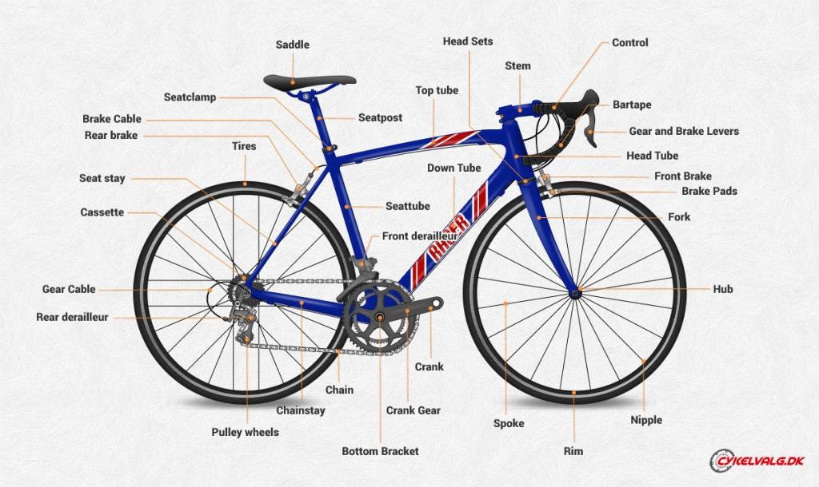

|  |  |
| --- | --- |
| Urbana    Mecánica // Maza Contrapedal Single Speed    Mecánica // Single Speed  Frenos y Palancas // Horquillas y Palancas al Manubrio | Híbrida |
|  |  |
| * Bottom Braket // Square Sealed Bearing 110mm * Crankset // 44 – 48 T * Free Wheel // 18 – 22 T * Chain // 96 Links * Rims Size // 700 * Tires // 700x28c * Fork Size // 700 Over 1 1/8 Straight – threadless * Headset // Over External 1 1/8 (31.8mm) * Seat Post // 27.2mm * Seat Clamp // 31.8mm Bolt * Steam // OVER – OVER 80mm * HandleBar // Riser OVER * Grips // MTB * Saddle // Bars * Peddals // 9/16 check compatibility with crankset | * Bottom Braket // Square Sealed Bearing 113mm or Hollow tech bearings * Crankset // 36D or 39-50D * Cassette // 8 – 10 steps (11/36-46) * Chain // Related to the number of steps * Transmition // 8 – 10 step Rear derailleur and Levers * Hubs // Quick Release 8 – 10 steps, Disc Brake ready, check compatibility with Rims (check hole count) * Front Derailleur – Only for double chainring, direct mount * Rims // 700 (32 o 36 holes) * Disc Brakes // 160mm Rotors (check compatibility with hubs), mechanical calippers, MTB levers, R160 + F160 adaptors * Tires // 700×32-40 * Fork // Over 1 1/8 Threadless (check compatibility with tire) * Headset // Over External 1 1/8 (31.8mm) * Seat Post // 27.2mm * Seat Clamp // 31.8mm Bolt * Steam // OVER – OVER 80mm * Handle Bar // Riser OVER * Grips // MTB * Saddle // Bars * Peddals // 9/16 (check compatibility with crankset ) |
| Wheel size 700  Tire 700×23-28  Rims 700 – 32 o 36 holes  Spokes 14G  Single Speed o Coasterbrake | Wheel size 700  Tires 700×32-40  Rims 29 – 32 o 36 holes  Hubs 32 o 36 holes (check compatibility with Cassette)  Cassette 8, 9, 10 u 11 steps (check compatibility with Hub)  Disc Brake Rotor (Center Lock or 6 Knots (check compatibility with Hub)  Spokes 14G |
| Fork Size 700  OVER 1 1/8  Threadless  Carbon, Aluminium, Steel or Bamboo | Fork Size 700  For wheels 700 x 32-80  OVER 1 1/8 Recta (NO CONIC)  Disc Brake or Vbrake Ready  Carbon, Aluminium, Steel or Bamboo |